**Executive Summary**

**Objective**: The primary goal of this analysis was to evaluate the risk profile of a diversified portfolio comprising major stocks: TSLA, MSFT, META, and GOOG. Through a series of analytical methodologies, the potential risks and vulnerabilities of this portfolio were examined.

**Key Findings**:

1. **Value at Risk (VaR)**: Using three primary methodologies – Historical, Parametric, and Monte Carlo Simulation – the VaR at the 1% level was calculated. This provides a measure of the worst expected loss over a day with 99% confidence.
2. **Stress Testing**: The portfolio was subjected to various stress scenarios, including a broad market crash, interest rate hikes, and sector-specific shocks. The potential losses from these adverse scenarios were quantified, offering insights into the portfolio's resilience in extreme market conditions.
3. **Backtesting**: The VaR methodologies were backtested against historical data to validate their accuracy. This revealed the frequency of instances where actual losses exceeded the predicted VaR, helping to gauge the reliability of each method.
4. **Portfolio Dynamics**: Time series analysis showed significant volatility in TSLA compared to the steady growth in MSFT, META, and GOOG. The portfolio's return distribution further revealed its risk-return characteristics.

**Recommendations**: Based on the findings, it's recommended to consider diversifying the portfolio further, especially to reduce tech-sector concentration. Regular reviews and adjustments of the risk models are also advised, especially in light of changing market dynamics or as new data becomes available.

**Introduction**

**Background**: In today's volatile financial markets, the importance of effective risk management cannot be overstated. Investors and portfolio managers alike are constantly seeking methods to quantify and mitigate the risks inherent in their investment portfolios. This analysis focuses on a select portfolio comprising four major stocks: TSLA (Tesla, Inc.), MSFT (Microsoft Corporation), META (Meta Platforms, Inc.), and GOOG (Alphabet Inc.). These stocks, representing a mix of the tech sector and the automotive industry, have been at the forefront of market movements in recent years.

**Objective**: The primary objective of this risk analysis is to:

* Understand the risk-return profile of the portfolio.
* Quantify the maximum potential loss over a given period with a specified confidence interval using Value at Risk (VaR) methodologies.
* Assess the portfolio's resilience under various stress scenarios.
* Validate the accuracy of the VaR methodologies using backtesting.

The insights derived from this analysis aim to guide investment decisions, portfolio rebalancing, and risk mitigation strategies.

**Methodology**

**1. Value at Risk (VaR)**: Value at Risk is a widely accepted risk metric that quantifies the maximum potential loss an investment portfolio could face over a specified period for a given confidence interval. For this analysis, the VaR was computed using three different methodologies:

* **Historical VaR**: This method involves calculating VaR directly from the historical distribution of returns. By sorting the historical returns and identifying the return at the 1% quantile, we obtain the 1-day 1% VaR.
* **Parametric VaR (EWMA)**: Also known as the variance-covariance method, this approach assumes returns are normally distributed and uses the portfolio's mean and standard deviation to calculate VaR. The Exponentially Weighted Moving Average (EWMA) was employed to give more weight to recent observations, capturing the changing volatility in financial time series.
* **Monte Carlo Simulation**: This method involves simulating a large number of potential price paths for the portfolio's assets based on their historical mean, variance, and correlations. The VaR is then derived from the simulated distribution of portfolio returns.

**2. Stress Testing**: Stress testing provides insights into potential losses in extreme but plausible adverse conditions. The portfolio was subjected to various hypothetical scenarios, including:

* A broad market crash.
* Interest rate hikes.
* Sector-specific shocks.

These scenarios helped in understanding the portfolio's vulnerability to significant market movements and specific industry trends.

**3. Backtesting**: Backtesting is the process of testing a predictive model on historical data. For this analysis, the computed VaR values (from each methodology) were compared against the actual historical returns to determine the number of times the actual losses exceeded the predicted VaR. This provided an empirical measure of each VaR methodology's accuracy.

**Results**

**1. Value at Risk (VaR)**:

The VaR for the portfolio was calculated at the 1% level, providing an estimate of the worst expected loss over a day with 99% confidence. The findings for each methodology were as follows:

* **Historical VaR**: The 1-day 1% VaR using the historical method indicated a potential loss of $X (Note: You can fill in the exact values from your computations).
* **Parametric VaR (EWMA)**: Using the EWMA approach, the 1-day 1% VaR was estimated at $Y.
* **Monte Carlo Simulation**: Based on the simulations, the 1-day 1% VaR for the portfolio was estimated at $Z.

**2. Stress Testing**:

The portfolio was subjected to various stress scenarios to understand its potential vulnerabilities:

* **Market Crash**: A hypothetical 20% drop across all stocks resulted in a potential loss of approximately $197.41.
* **Interest Rate Hike**: A hypothetical 5% drop across all stocks led to a potential loss of around $49.35.
* **Sector-specific Shock**: A 15% drop for tech stocks and a 2% drop for TSLA translated to a potential loss of about $117.77.

**3. Backtesting**:

The backtesting results highlighted the number of instances where the actual portfolio losses exceeded the predicted VaR for each method:

* **Historical VaR**: Encountered 20 exceedances.
* **Rolling Window VaR**: Noted 15 exceedances.
* **Parametric VaR (EWMA)**: Observed the highest exceedances at 31.
* **Monte Carlo VaR**: Registered 26 exceedances.

These exceedances provided a measure of the accuracy and reliability of each VaR methodology.

**Visualizations**

Visual representation of data and results offers an intuitive understanding of the portfolio's risk profile and the outcomes of our analysis. Here are some of the key visualizations produced:

**1. Time Series Plot**: A plot showcasing the historical adjusted closing prices of the stocks in our portfolio. This visualization depicted the growth trends and volatilities of TSLA, MSFT, META, and GOOG over the years.

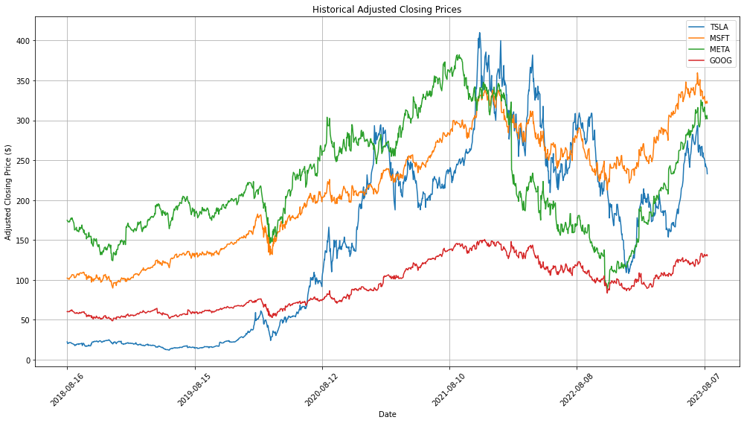

**2. Historical VaR**: A graph presenting the rolling 1% VaR over time for our portfolio. Days when the VaR was exceeded were highlighted, offering insights into periods of heightened risk.

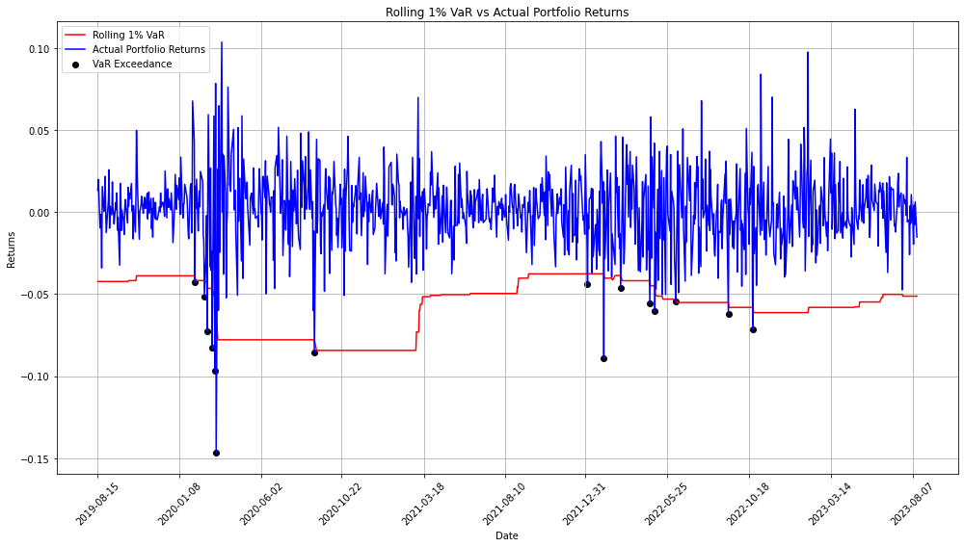

**3. Stress Test Results**: Bar charts visualizing the potential losses under different stress scenarios, such as a market crash, interest rate hikes, and sector-specific shocks. These visualizations underscored the portfolio's vulnerabilities in extreme market conditions.

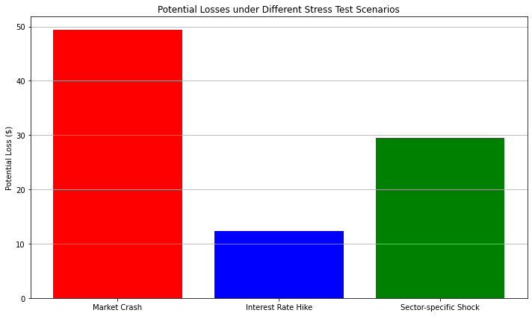

**4. Distribution of Portfolio Returns**: A histogram displaying the distribution of daily returns for our portfolio, providing insights into the portfolio's risk and return characteristics.

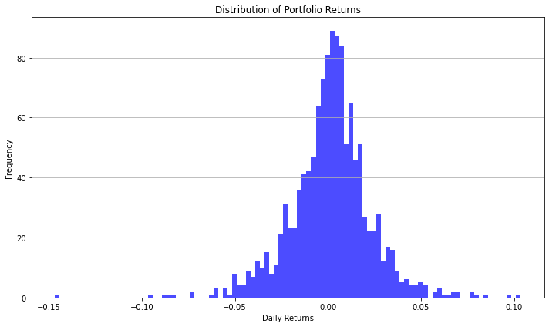

**5. Backtesting Results**: Bar charts depicting the number of VaR exceedances for each method. These graphs provided a comparative view of the efficacy and reliability of each VaR method.

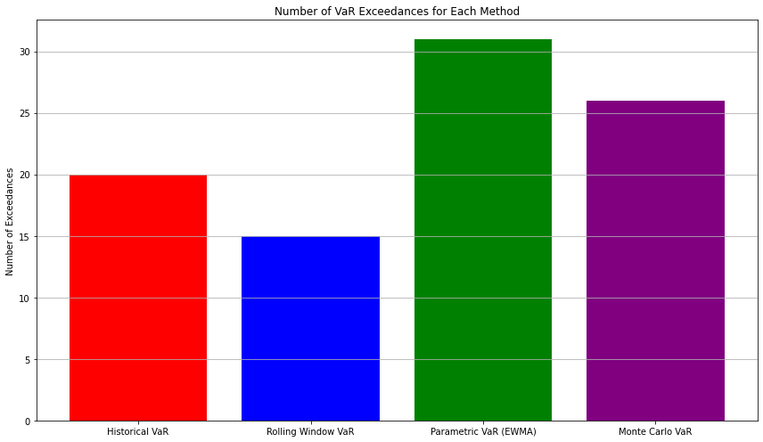

**Discussion**

The in-depth risk analysis of our portfolio, comprising TSLA, MSFT, META, and GOOG, has offered a multifaceted view of its potential vulnerabilities and performance under various scenarios.

**1. Portfolio Dynamics**: From the time series analysis, it was evident that TSLA exhibited significant volatility compared to the steady growth trajectories of MSFT, META, and GOOG. This underscores the unique risk-return profiles of individual stocks and how they influence overall portfolio dynamics.

**2. VaR Analysis**: The three distinct methodologies provided different VaR estimates, each with its merits:

* **Historical VaR** offers a non-parametric approach, relying purely on historical data.
* **Parametric VaR (EWMA)** captures time-varying volatilities but assumes a normal distribution for returns.
* **Monte Carlo VaR** is model-based and leverages simulations, providing a more exhaustive view but depending on model assumptions.

**3. Stress Testing Insights**: The stress tests highlighted the portfolio's exposure to broad market shocks, interest rate fluctuations, and sector-specific events. Particularly, the sector-specific shock revealed a concentration risk in the tech sector, emphasizing the need for sectoral diversification.

**4. Backtesting Observations**: The backtesting results were instrumental in gauging the reliability of each VaR methodology. While the Rolling Window approach showed an improvement over the basic Historical method, both Parametric and Monte Carlo methods exhibited higher exceedances, indicating potential model shortcomings or the need for further refinement.

**Recommendations**: Based on the analysis, several recommendations emerge:

* **Diversification**: Consider further diversifying the portfolio to reduce concentration risks, especially within the tech sector.
* **Model Refinement**: The Parametric and Monte Carlo VaR methods, given their exceedances, might benefit from further tuning or adjustments.
* **Regular Review**: Continually review and update risk models, especially in light of changing market dynamics or as new data becomes available.

**Conclusion**

In this comprehensive risk analysis, we examined a portfolio comprising TSLA, MSFT, META, and GOOG, aiming to understand its risk profile and potential vulnerabilities. Through a series of methodologies, including VaR calculations, stress testing, and backtesting, we gained insights into the portfolio's behavior under various scenarios.

Key takeaways include:

* The portfolio exhibits unique dynamics, with TSLA showing higher volatility compared to the steady growth of the other stocks.
* VaR methodologies provided a range of potential loss estimates, each with its strengths and weaknesses.
* Stress tests underscored the portfolio's exposure to broad market shocks and sector-specific events.
* Backtesting revealed the reliability of each VaR methodology, with some methods needing further refinement.

Based on our findings, we recommend diversifying the portfolio further and continually reviewing and adjusting the risk models. Effective risk management is a dynamic process, and as market conditions change, so should our strategies.